Review the Oceans and Continents.  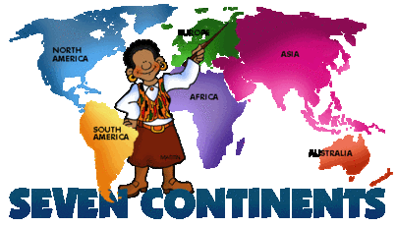  This Photo by Unknown Author is licensed under CC BY-SA | Plant something such as a flower or herb in the backyard or a pot. Watch it grow over the summer. What does it need to grow? | Practice telling time to the hour, ½ hour, minute on an old-fashioned clock.  (not digital)  This Photo by Unknown Author is licensed under CC BY-NC-ND | At night look at the stars. Find a famous constellation or two.  Summer Math/Science/Social Studies Bingo | Spend 15 minutes working on memorizing addition facts 0-10.
Practice Multiplication facts 0-5 five days in a row! | Have a pizza night – Discuss “What fraction of Pizza each person ate?”  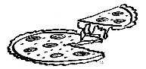  This Photo by Unknown Author is licensed under CC BY | Listen to the 50 states song.  https://www.youtube.com/  watch?v=_E2CNZIIVIg  (Google if that doesn’t work) | Count the change in your piggy bank or Mom’s purse!  This Photo by Unknown Author is licensed under CC BY-NC-ND | Create an obstacle course outside. Calculate your average time to complete the course over a series of 5 attempts. Get a friend to try it!
Listen to the Water Cycle Song. https://www.youtube.com/  watch?v=T05djitkEFI | Spend 15 minutes working on memorizing subtraction facts 0-10. | Practice identifying the 50 states on a map. | Play a game of YAHTZEE!  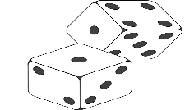  This Photo by Unknown Author is licensed under CC BY-SA | Stack the States  Free app.
Work on State Capitals  with this fun website: https://mrdonn.org/  geography.html  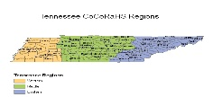  This Photo by Unknown Author is licensed under CC BY | Design and build a bird feeder. How many birds can you attract?  What kinds of birds came? | Play the Game of Life or Monopoly  And be the Banker!  This Photo by Unknown Author is licensed under CC BY-NC-SA | Fill a clear container ¾ with vegetable oil. Fill the rest with water and add 10 drops food coloring. Drop in an Alka-Seltzer tablet. You have a lava lamp! | How many countries can you name in Europe? Can you do better?
Design a math scavenger hunt for some friends.  Play Date! | Moby-Max  Fact Master  3 days 10 minutes a day [Student Resources] | Work on learning your addition and subtraction facts 0-10 in less than 5 minutes! | Name 5 countries in Africa.  Check your answers on a map of Africa.  Date________________ | Create a map of your dream playground. (Include distance, area, perimeter, Compass Rose, Key)
Directions: Have an adult initial each box you complete over the summer. Return the board with BINGO for a 3rd grade treat. 1 line or Blackout board.
NAME: ________________________________________________

